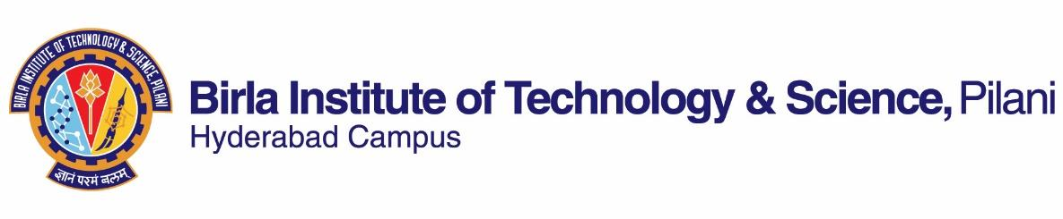

**SECOND SEMESTER 2018-2019**

# Course Handout Part II

Date: 07-01-2019

In addition to part-I (General Handout for all courses appended to the time table) this portion gives further specific details regarding the course.

**Course No: BITS F399**

**Course Title: Humanistic Theories of Science and Technology**

**Instructor: Biswanath Dash**

**Room No. C212**

**Email: biswanath@hyderabad.bits-pilani.ac.in**

**1. Objective and scope of the course:**

This course will introduce ways of considering the interrelationship among three major dimensions of our culture-- science, technology and humanistic orientation. The main focus of the course will be to understand various theories that explain the relationship between science, technology and society. In the process, the students will learn alternate ways of thinking about science and technology, and will be encouraged to question the taken for granted ideas about scientific knowledge and technological artifacts.

**2. Text Book:**

Sismondo, Sergio. 2004. *An introduction to Science and Technology Studies*. UK: Blackwell Publishing.

**3. Reference Material:** Will be announced in the class.

**4. Course Plan:**

|  |  |  |  |
| --- | --- | --- | --- |
| **Lecture**  **No.** | **Learning Objective** | **Topics to be covered** | **Text Book and Ref. material** |
| 1-2 | Understanding the core concepts | Science, Technology, Humanities : their Interrelationship | TB Chapter 1 |
| 3-14 | To get an introduction to various conceptual and key theoretical debates concerning science and its method | Rationality- Key thinkers, Plato, Descartes, Chomsky etc.  Empiricism- Francis Bacon, John Locke etc.  Evolution of Scientific Method- Galileo, Newton etc. | Reading materials |
| 15-20 | Develop a perspective on ‘Science and Technology Studies’ (STS) | Understanding growth of science- Popper and Kuhn  Criticisms- Paul Feyerabend  Synthesis: Lakatos | TB Chapter 2,  Reading material |
| 20-24 | Gain a perspective on ‘Sociology of Science’ | Institutional view of science,  Sociology of Knowledge and  Introduction to Social construction | TB-Chapter 3-6 |
| 25-35 | To critically analyze ‘social constructivist’ framework | Mutual shaping of science, technology and society.  Social Construction of Technology;  Actor Network Theory;  Laboratory studies | Reading materials,  TB Chapter 7,8, 9, 10,11,12 |
| 36-42 | To reflect on critical and cultural studies of science and technology | Gender and science;  Public Understanding of Science;  Science Communication | TB Chapter 15 and 16, Reading materials |

**5. Evaluation Scheme:**

|  |  |  |  |  |  |
| --- | --- | --- | --- | --- | --- |
| **EC No.** | **Evaluation Component (EC)** | **Duration** | **Weightage** | **Date, Time and Venue** | **Nature of Component** |
| 1. | Mid Semester Test | 90 min | 30% | 15/3  9.00 - 10.30AM | Closed Book |
| 2 | Assignment 1 & 2 |  | 30% |  | Open Book |
| 3. | Comprehensive Examination | 180 min | 40% | 10/05 FN | Closed Book |

**6. Course Notices:** Notices, if any, will be displayed on Department Notice Board and CMS.

**7. Make-up:** For the components of the evaluation, makeup will be allowed on the basis of documented proof to support the case. If you have a personal or medical emergency, provide copies of the appropriate paperwork to your instructor as soon as you can. Missing a due date, forgetting an assignment, or simply getting behind is not a valid reason.

**8. Plagiarism:** Please be aware that cutting and pasting from websites is considered plagiarism. Students are advised to document all sources. If you are not sure that you need to document a source, then please ask the instructor. Any hint of plagiarism in assignment will fetch a zero.

**9. Chamber consultation:** Thursday 11-12.

**10. Academic Honesty and Integrity Policy:** Academic honesty and integrity are to be maintained by all the students throughout the semester and no type of academic dishonesty is acceptable.

**Biswanath Dash**

**INSTRUCTOR-IN-CHARGE**